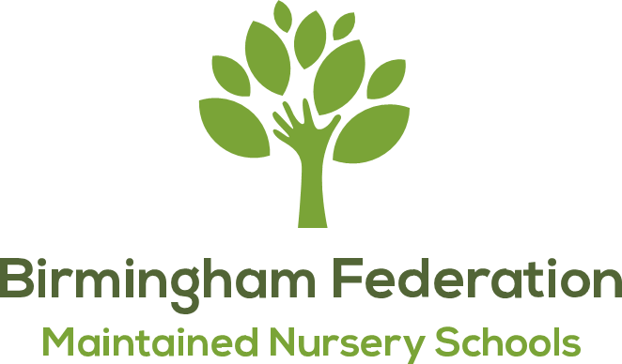

13.04.2026
PARENT GOVERNOR ELECTION OUTCOME
Dear Parent/ Carer,
Following our Parent Governor election nominations process and follow up ballot process before the Easter break, I am pleased to share the outcome of the election with you.
The ballot letter was shared with the parent/carer body at all 9 Birmingham Federation of Maintained Nursery Schools and a ballot response period was open for 5 working days. All votes were then counted and collated.
The election has been decided by a majority of votes cast.
There was 1 withdrawal of nomination.
There are 2 successfully elected parents to the role of Parent Governor on the BFMNS Full Governing Board:
Aimee Blake and Rumman Amir Zaidi
We look forward to working with Aimee and Rumman.
Thank you for taking the time and trouble to support this election.
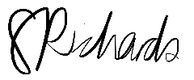
Yours faithfully,

Samantha Richards - Executive Head Teacher
Returning Officer

